**Step 1: Setup Git Configuration**

**Description:**  
Installed Git Bash and configured username and email.

**Commands Used:**

git --version

git config --global user.name "SRISWASTHIKA A"

git config --global user.email "sriswasthika.ashok@gmail.com"

git config --global --list

**Screenshot(s):**  
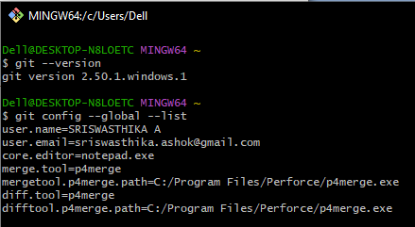

**Step 2: Integrate Notepad++ with Git**

**Description:**  
Configured Notepad++ as the default Git editor.

**Commands Used:**

notepad

git config --global core.editor "notepad -multiInst -notabbar -nosession -noPlugin"

git config --global -e

**Step 3: Create Local Repository**

**Description:**  
Created a folder GitDemo and initialized it as a Git repository.

**Commands Used:**

cd /c/Users/Dell/GitDemo

cd /c/Users/Dell/GitDemo

git init

**Step 4: Add File to Repository**

**Description:**  
Created welcome.txt file and committed it.

**Commands Used:**

echo "This is a log file" > app.log

git add .gitignore welcome.txt

git commit -m "Add welcome.txt and .gitignore to ignore log files and folders"

**Screenshot(s):**  
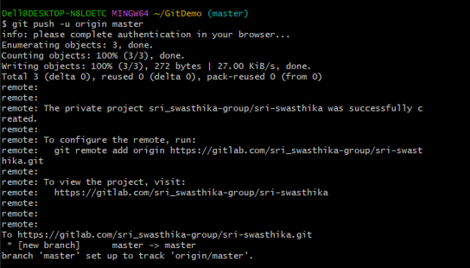

**Step 5: Push to Remote Repository**

**Description:**  
Created GitLab repository and pushed local commits to it.

**Commands Used:**

git remote add origin https://gitlab.com/sri_swasthika-group/sri_swasthika-project.git

git push -u origin master

**Screenshot(s):**

